**Design of Simple** **Board Game for Augmented Reality**

**김수균, 단효운, 최민형**

**Abstract**

AR (Augment Reality) is the integration of digital information with the user's environment in real time [1]. AR is developed based on VR(Virtual Reality), unlike virtual reality, which creates a totally artificial environment, augmented reality uses the existing environment and overlays new information on top of it. In this paper, we made a board game that can allow multiplayers to play in a combination of realistic and virtual space. In this Board Game, there are 3 characters with different colors and several buttons to control the characters.

1. **Introduction 완료**

Augmented reality (AR) integrates computer display into real-world environments and enhances environment of real world. AR is spread in our life such as game, study, work and traveling. Recent AR games provide a new type of gaming experience with smart phone users in everywhere. Recent hardware platforms for augmented reality include computers with webcam, smartphones, glasses, head mounted display and haptic devices.

The aim of this paper is to create simple board game in augmented reality using both Unity 3D [3] and Vuforia SDK [2] **(원래 교수님 쓰신 2번 인데 원래 2번 없는 거 같아요).** that is for creating AR applications in mobile devices. Vuforia was originally developed by Qualcomm and optimized for their chipsets aiming primarily at mobile performance. The features of Vuforia are extremely varied range of marker types, aggressive development

1. **Board Game 완료**

A player has played on a specially designed board. The games have been played in most societies and cultures throughout history [4]. Especially the games that are based on strategy placed on a pre-marked surface according to a set of rules [4]. Molla et al. have been studies how to transform actual game into game of Augmented Reality by using a simple webcam [5]. For mobile AR games are several interaction studies like the potential of interaction based on finger movement via camera [6]. The Sphero [7] focuses on both tangible interfaces and physical around players and increases enjoy ability and immersion. Vancouver Maneuver [8] has created a cooperative board game experience by using Augmented Reality for mobile devices. The game provides both digital and analogue board game design like hybrid game design approach.

1. **Design of Board Game for Augmented Reality**

Vuforia is an AR Software Development Kit (SDK) for mobile devices that enables the creation of AR applications[2]. 🡪 참고문헌 2가 맞니??? **(지금 맞습니다).** We use Vuforia SDK to create AR environment including Vuforia SDK For Unity - vuforia-unity-6-2-10 unity package. This package will be import to unity and used as the board in the game. We import vuforia package, image package (**이 package는 Vuforia site 에서 생성된 것이다**)and the model package into unity, drag and drop the ARCamera and ImageTarget prefabs into the Hierarchy panel, and then we set up the Vuforia Behaviour **by paste the License Key(can get it on Vuforia site) to the Vuforia Configuration**, making a script named ”move.cs” to control the movement of models. Figure 1 shows flowchart, and the direction buttons control the models’ movement, up for forward, down for back, and the 'change' button is to switch the model among 3 different colors. The blue part is the camera area. 🡪 내가 수정해 보았는데, 맞는지 확인해 줄래. 그리고 그림 1의 파란색이 카메라 영역이 맞니**? (확인 했습니다.)**

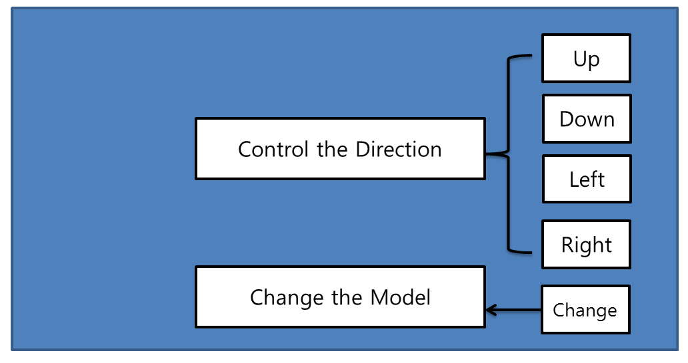

Fig 1. Flowchart

1. **Experiments**

The Experimental environment for this development is Intel(R) Xeon(R)CPU E3-1240 v3 @3.40GHz 3.40GHz, RAM 8GB with window 10 and using software include version 5.5.2f1 personal (64bit) of Unity3D and vuforia unity-6-2-10 unity package for AR. We have implied the game in a mobile device such as an android. Fig. 2 shows the result of designed game.

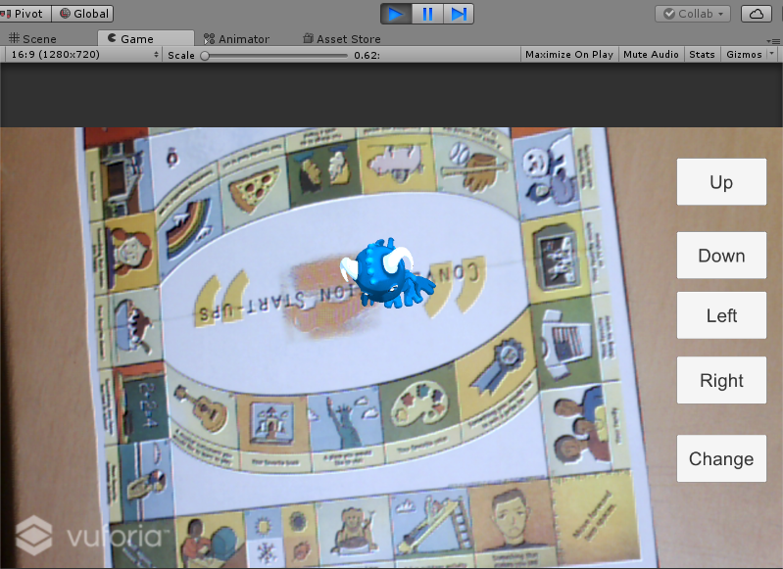 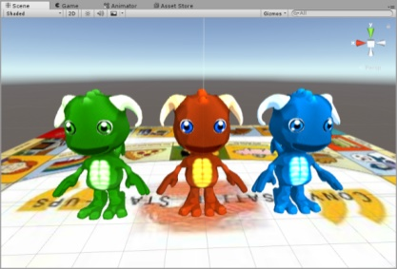

(a) Beginning the game (Game Scene) (b) Game Models

Fig 2. Result of designed Game

1. **Conclusion 김수균**

**Reference**

**번호를 자동 배정한 거라서 문제가 생긴 거에요, 제가 다시 배정 했어요 1,2 번은 제가 추가 한 거고 나머지는 교수님 쓰신 거에요, 3번 Unity3d Link 만 잘 못 된 거 같아요 교수님 다시 넣으세요.**

1,AR, http://whatis.techtarget.com/definition/augmented-reality-AR, [Article(CrossRef Link)](http://whatis.techtarget.com/definition/augmented-reality-AR)

2,Vuforia SDK, https://developer.vuforia.com/, [Article(CrossRef Link)](https://developer.vuforia.com/)

3,Unity 3D, [Article(CrossRef Link)](https://madewith.unity.com/)

4,Dhiraj Amin and Sharvari Govilkar, “COMPARATIVE STUDY OF AUGMENTED REALITY SDK’S”, International Journal on Computational Science & Applications (IJCSA), Vol.5, No.1, 2015. [Article(CrossRef Link)](http://www.metaio.eu/)

5,Wikipedia - Board Games, [Article(CrossRef Link)](https://en.wikipedia.org/wiki/Board_game)

6,E Molla, V Lepetit, “Augmented reality for board games”, Mixed and Augmented Reality (ISMAR), 9th IEEE International Symposium, 22 November 2010.

7,Hürst, W., Vriens, K., “Mobile augmented reality interaction via finger tracking in a board game setting”, Workshop Paper (2013).

8,Jones, B., Dillman, K., Manesh, S.A., Sharlin, E., Tang, A.,”Designing an immersive and entertaining pervasive gameplay experience with spheros as game and interface elements”, In: Proceedings of the First ACM SIGCHI Annual Symposium on Computer-Human Interaction in Play, CHI PLAY 2014 (2014)

9,A. Golombek, M. Lankes, J. Hagler, “Vancouver Maneuver: Designing a Cooperative Augmented Reality Board Game”, Entertainment Computing, ICEC 2016, Vienna, Österreich, 2016, pp. 286-289